# Project Introduction

Customer Personality Analysis is a detailed analysis of a company’s ideal customers. It helps a business to better understand its customers and makes it easier for them to modify products according to the specific needs, behaviors and concerns of different types of customers.

Customer personality analysis helps a business to modify its product based on its target customers from different types of customer segments. For example, instead of spending money to market a new product to every customer in the company’s database, a company can analyze which customer segment is most likely to buy the product and then market the product only on that particular segment.

# Analysis OBjectives

Here are the list of question whose analysis which be given below.

1. Data Analysis using statistical methods.
2. Data Analysis using conditional filtering when Marital_Status is Single.
3. Data Analysis using conditional filtering when Education is PhD.
4. Data Analysis by grouping the data on the basis of Education.
5. Data Analysis using sorting the data in ascending/descending order.
6. Data Analysis after sorting the data on the basis of ID, filtering ony PhD students and group by on their marital status.
7. Data Analysis after sorting the data on the basis of ID, filtering ony Single and group by on their Education status.
8. Visualize data of expenditure on the basis of Education using a chart with proper headings and legends.
9. Visualize data of wine expenditure on the basis of Education using a chart with proper headings and legends.
10. Visualize data of Fruits expenditure on the basis of Education using a chart with proper headings and legends.

# Data Acquisition and Cleaning

**Code to read the data from Excel / CSV / HTML.**

To read the dataset in xlsx format, we will load it into Pandas data frame but first let’s import the pandas library and set an alias by typing **“import pandas as pd”**. After importing the library with the alias **“pd”**, let us load the .csv file using the following line of code:

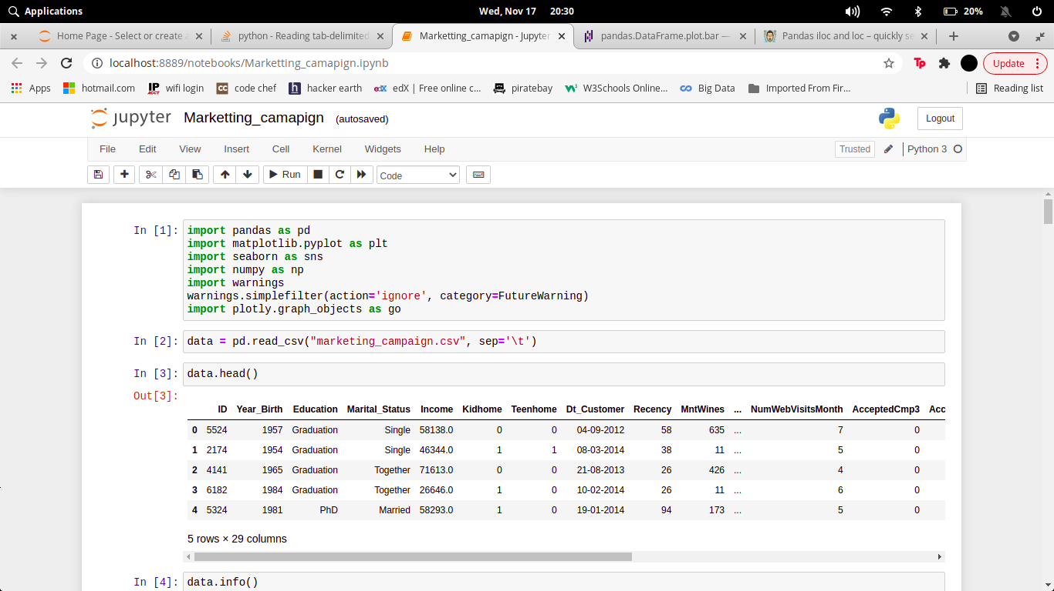

Here we have import our csv files and read through pandas library.

Here the xlsx file can be read through (Pandas library) and store in **data Dataframe**. The Dataframe can be shown through **.head()**. The number of rows we want to show, that number we have to pass in head parentheses as an argument.

Now if we want to describe our dataframe for our better understanding to know the stats. and other parameter that our dataset should follow

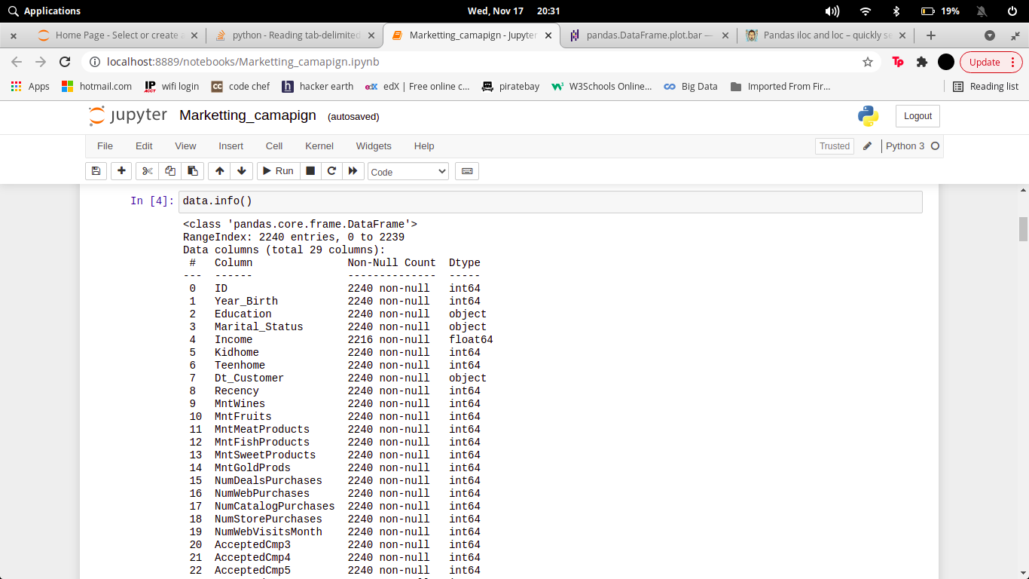

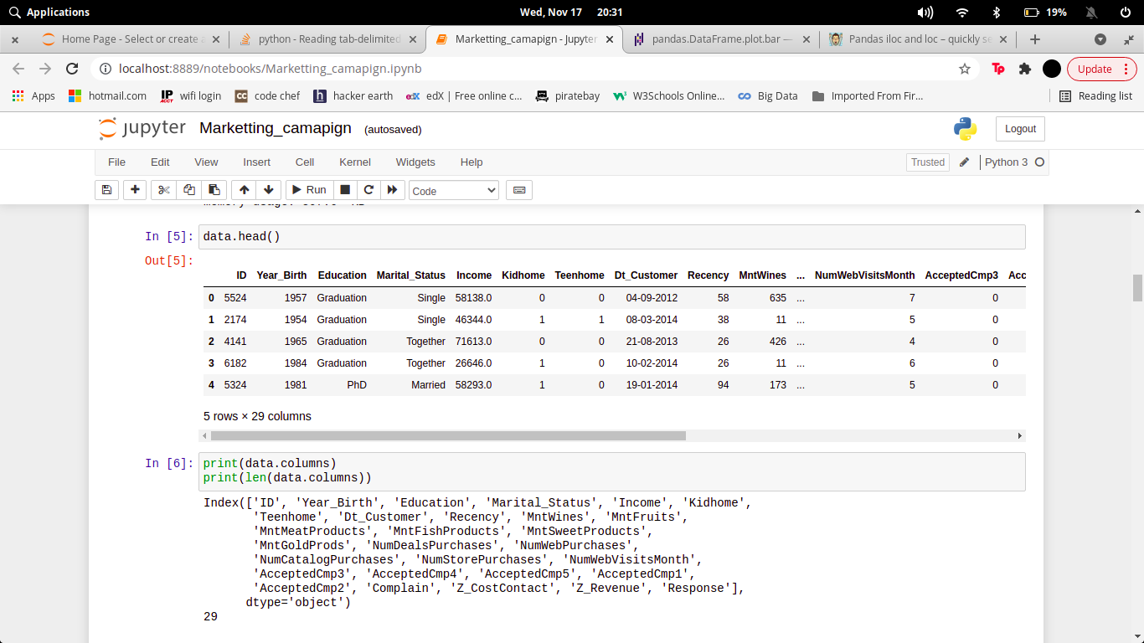

**Clean the unnecessary data, by removing, replace the missing data and renaming the columns.**

Dataset generally contains some null value, which is generally caused by misplacing some values. So its necessary to clean this mess from our dataset for better visualization

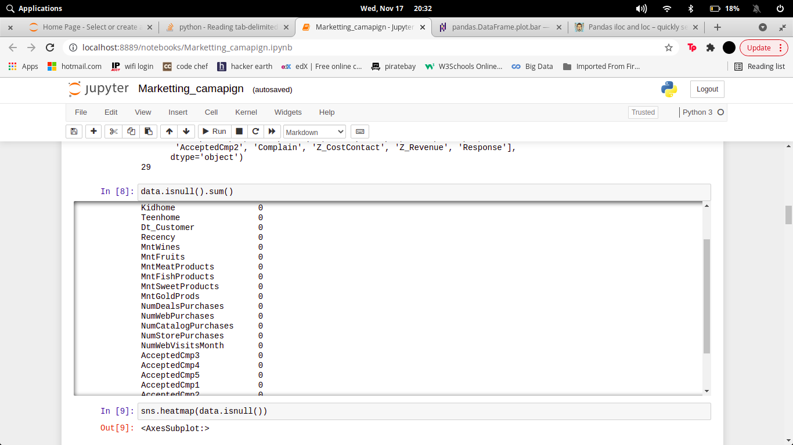

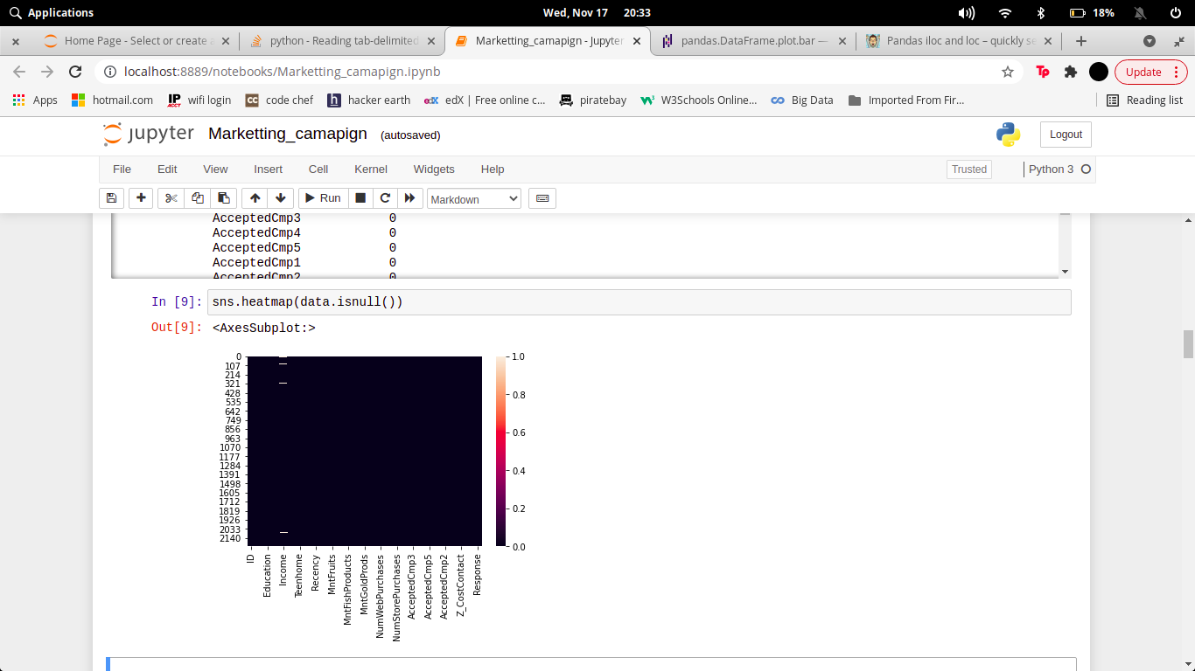

In the above diagram we see there is no columns of this dataset containing null value.

# Data and Exploratory Analysis

**Code and its output with Explanation**

1. **Data Analysis using statistical methods.**

This data gives the estimated amount to various statistical methods that can be applied.

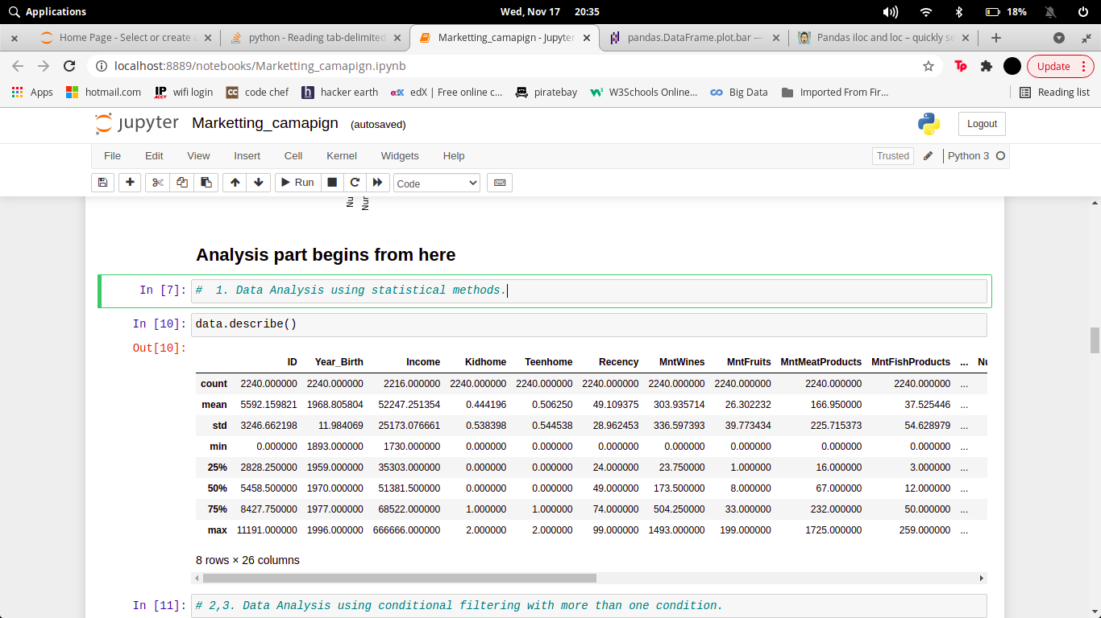

1. **Data Analysis using conditional filtering when Marital_Status is Single.**

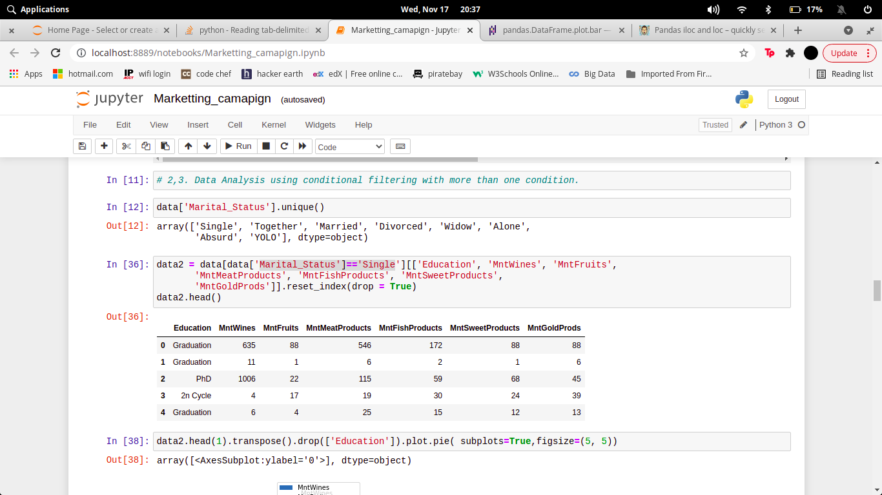

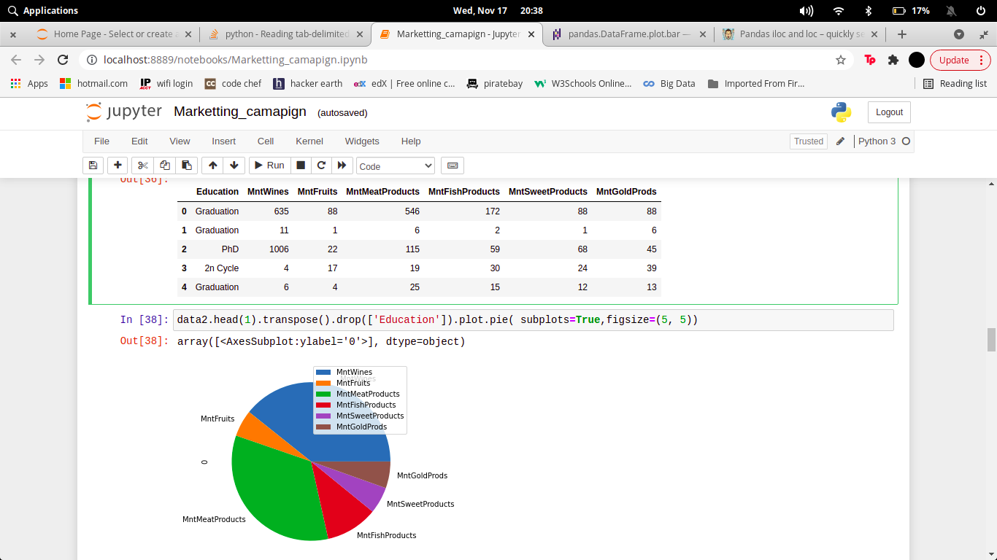

1. **Data Analysis using conditional filtering when Education is PhD.**

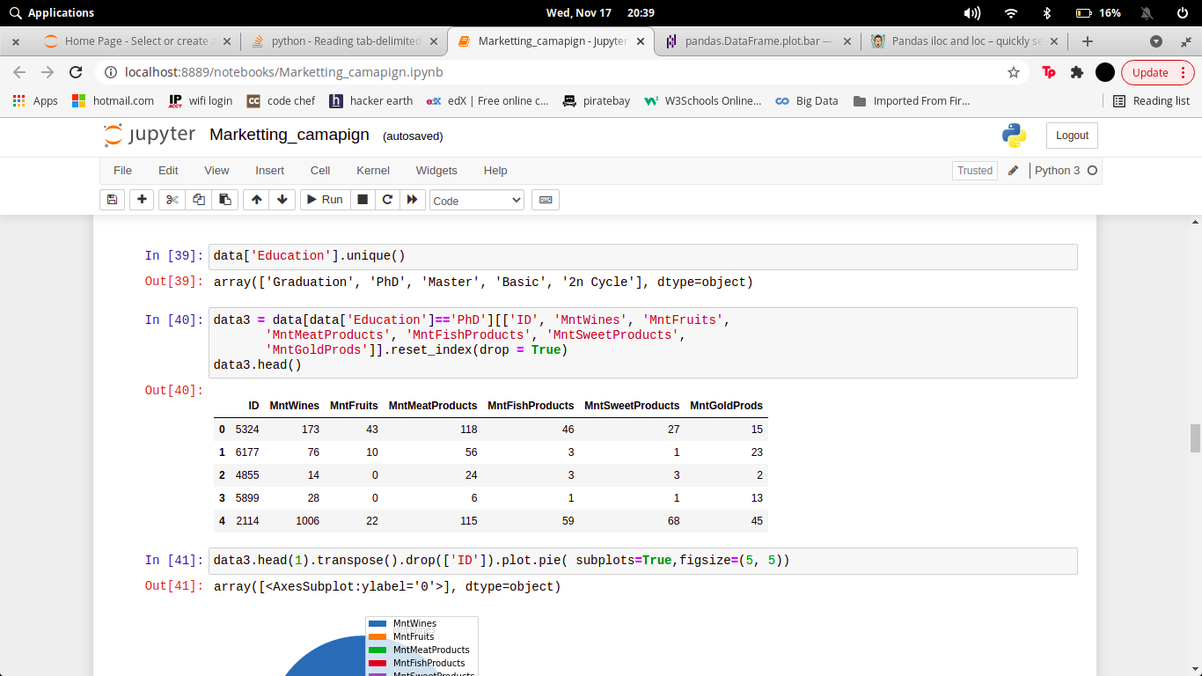

1. **Data Analysis by grouping the data on the basis of Education.**

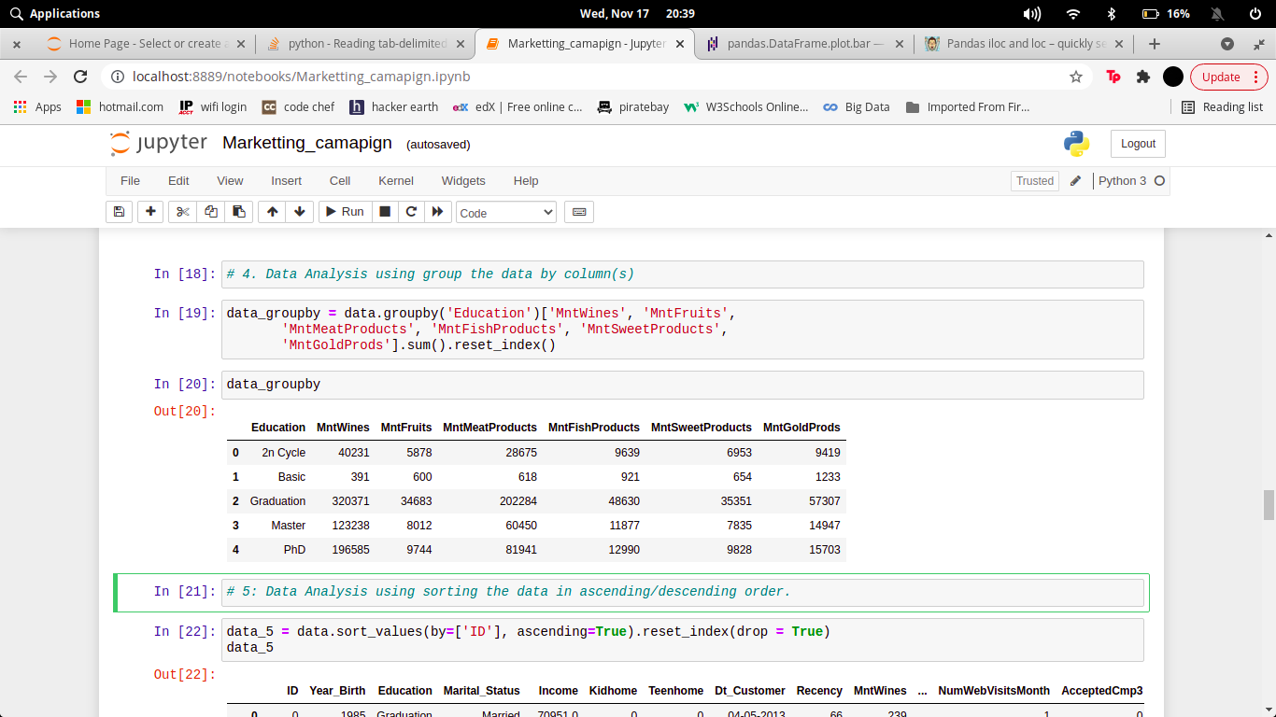

1. **Data Analysis using sorting the data in ascending/descending order.**

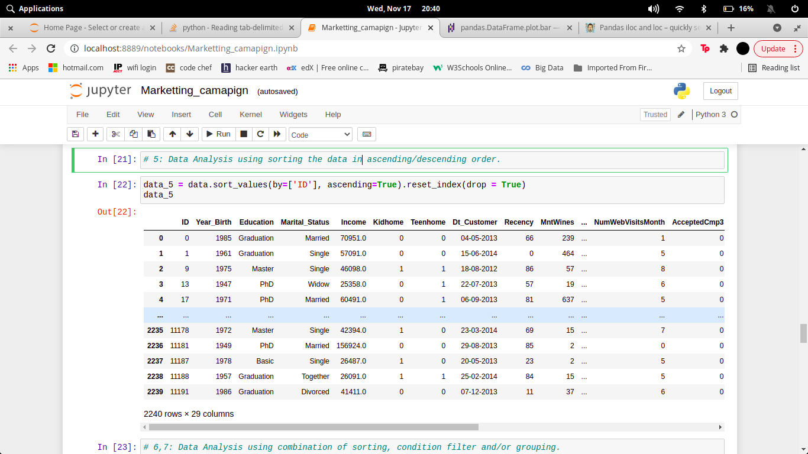

1. **Data Analysis after sorting the data on the basis of ID, filtering ony PhD students and group by on their marital status.**

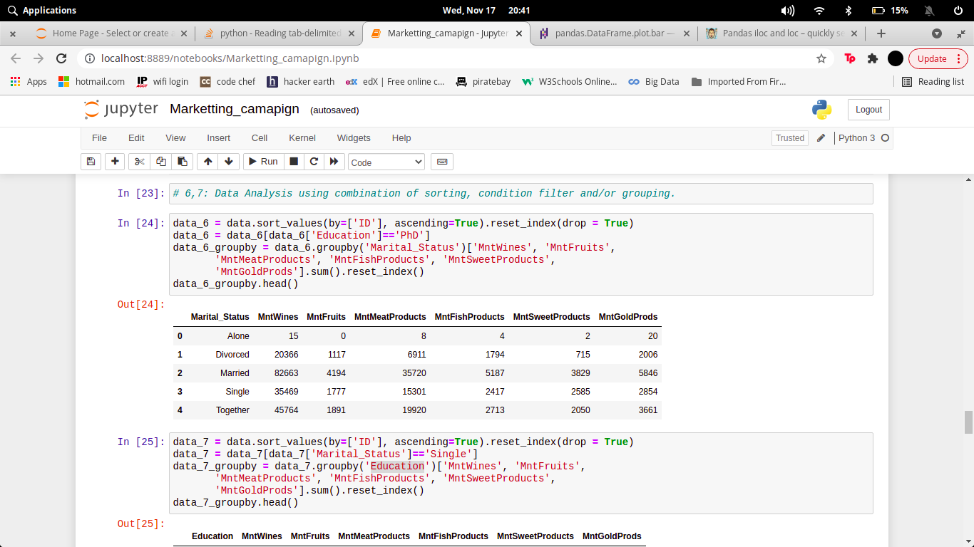

1. **Data Analysis after sorting the data on the basis of ID, filtering ony Single and group by on their Education status.**

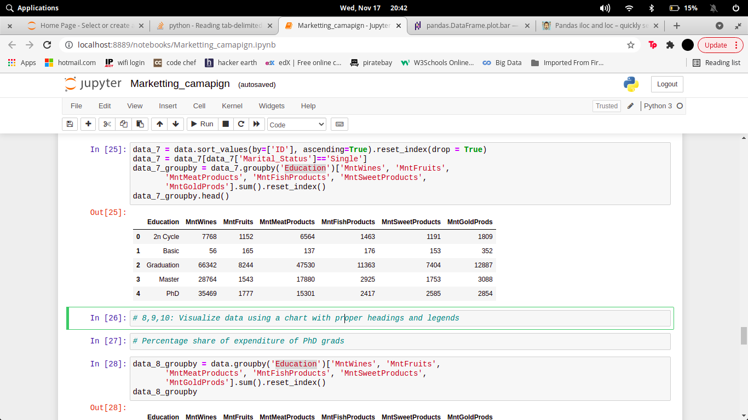

# Data Analysis – Visualization

**Code and its output with vizualization**

1. **Visualize data of expenditure on the basis of Education using a chart with proper headings and legends.**

**Code:-**

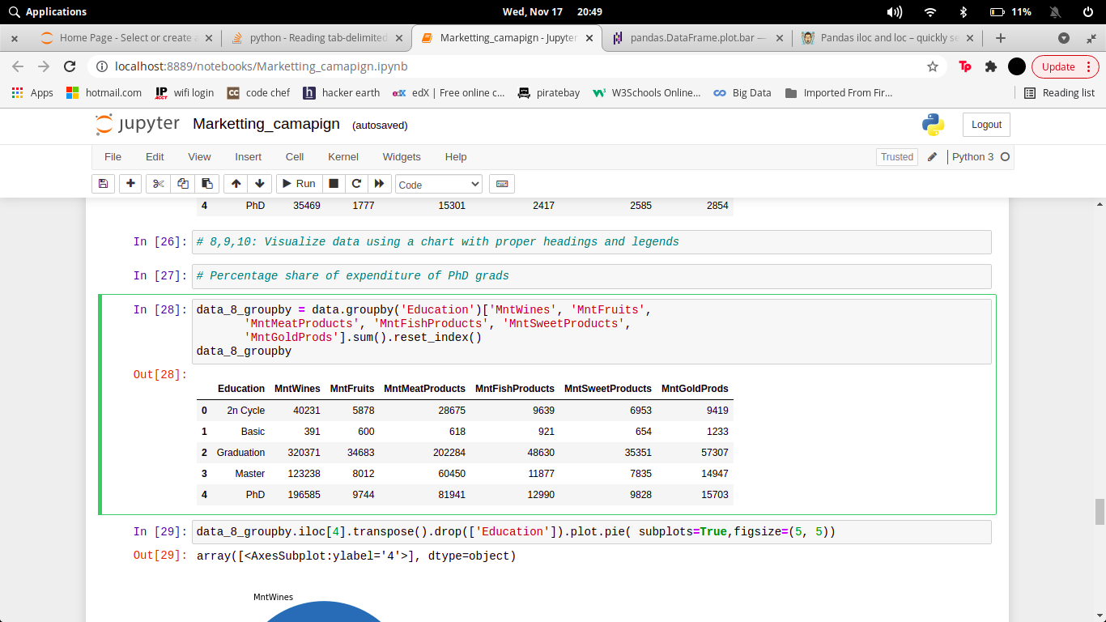

**Output:-**

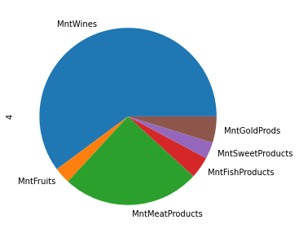

1. **Visualize data of wine expenditure on the basis of Education using a chart with proper headings and legends.**

**Code:-**

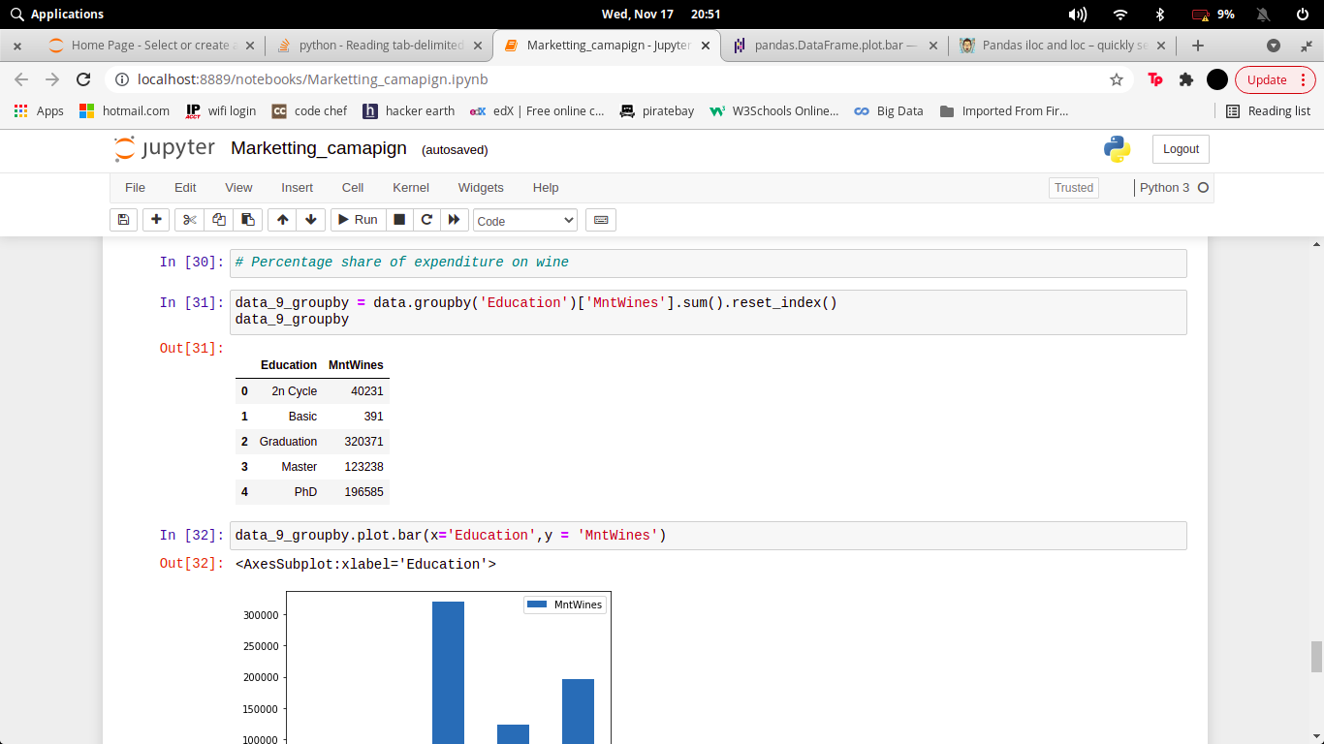

**Output:-**

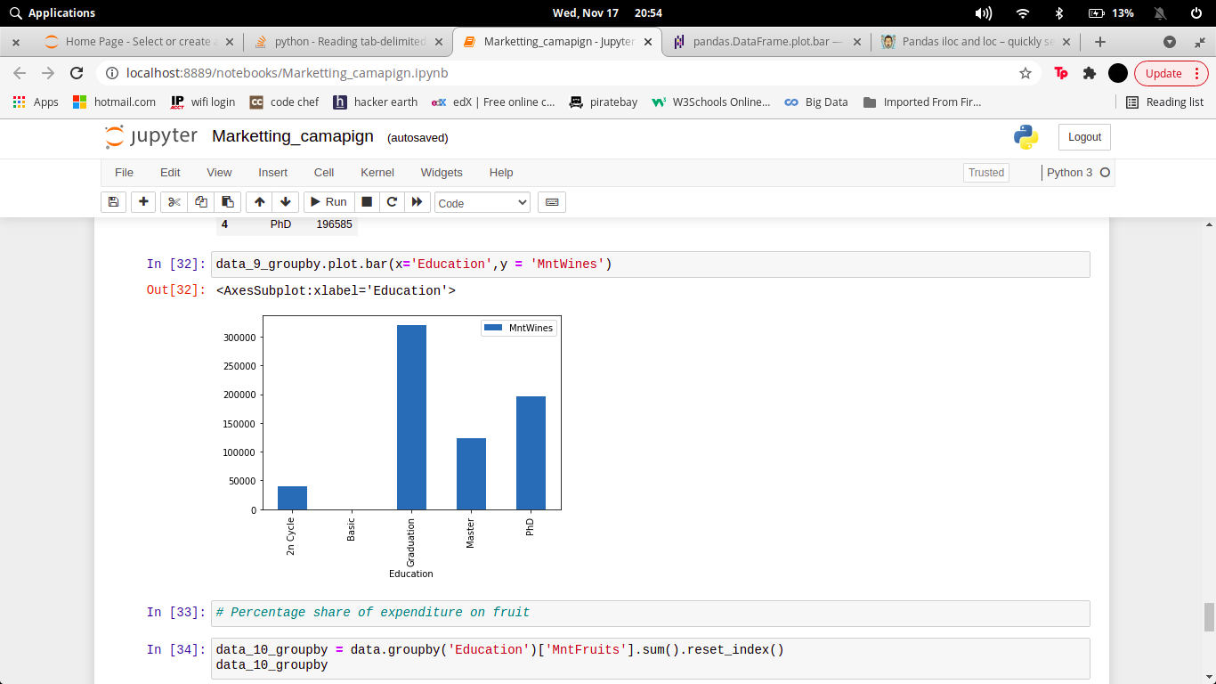

1. **Visualize data of Fruits expenditure on the basis of Education using a chart with proper headings and legends.**

**Code:-**

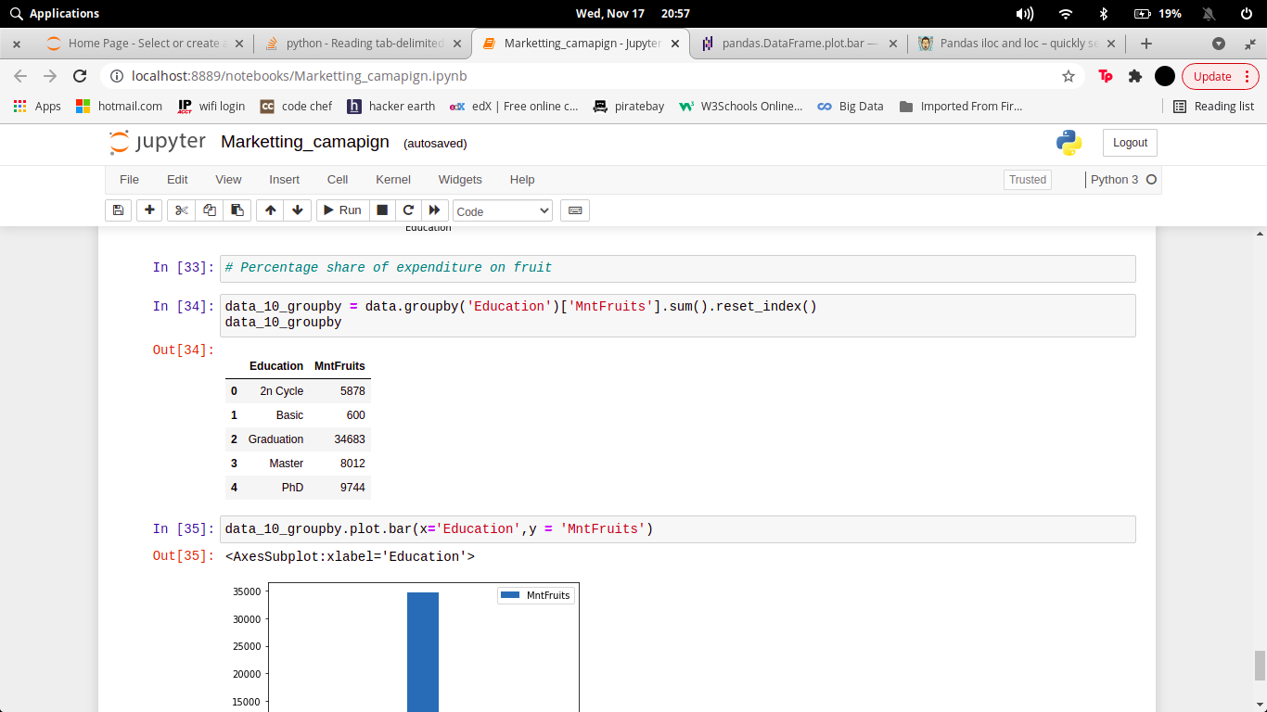

**Output:-**

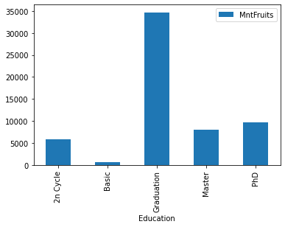

# Executive Summary

**CONCLUSION**

From the above observations, we concluded that the biggest customers of wines are:

1. Customers with an average income of around $69,500.
2. Customers with an average total spend of approximately $1,252.
3. Customers registered with the company for approximately 21 months.
4. Customers with a graduate degree.
5. And customers who are also heavy consumers of meat products.

# References

* https://pandas.pydata.org/docs/
* https://www.kaggle.com/imakash3011/customer-personality-analysis
* https://www.w3schools.com/python/pandas/pandas_plotting.asp